Task3: Using BVM hacking tool

We are using BVM hacking tool to inject virus in victim’s device to control or do some malicious activity like delete c drive, disable mouse etc.

In this we are using windows 10 as hackers PC and victims as Windows 7.

We are not using any dangerous commands like delete c drive file but instead we are using disabling the mouse option and change time because it does not harm the Virtual machine much.

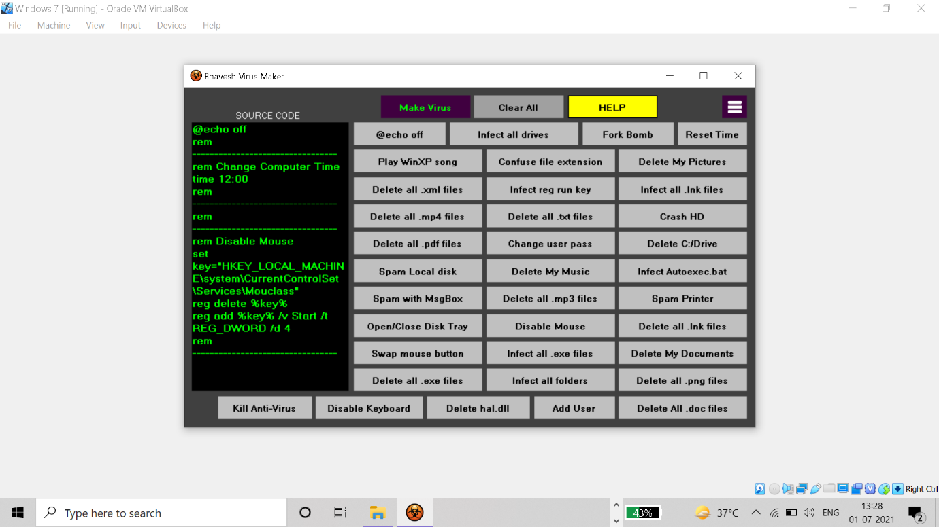

In this we first installed Bhavesh Virus Maker from the internet and install it.

But to make it run disable **real time scanning** and **firewalls** because it is a dangerous tool.

Then make a virus by make virus option.

We have made a new virus file named as “New Virus”.

And injected in victim’s device by pen drive.

We can transfer it by pen drive or any other physical device.

We can give it unknowingly to the victim by email etc.

Once it is open the actions start to take place and the actions you have choose start to take place.

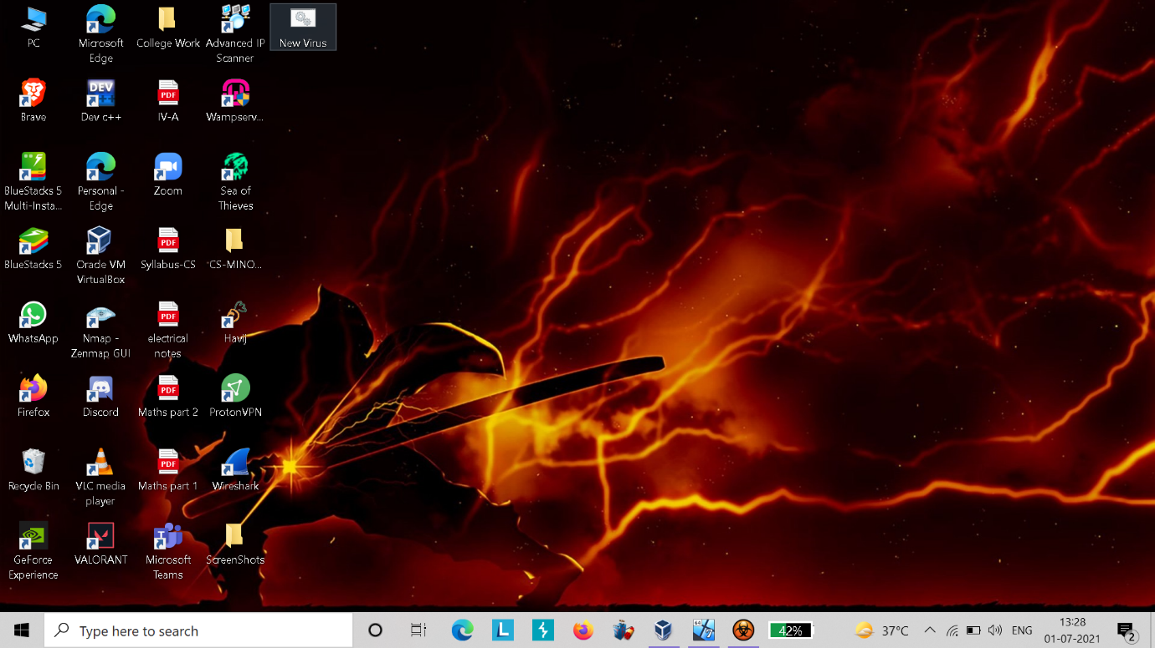

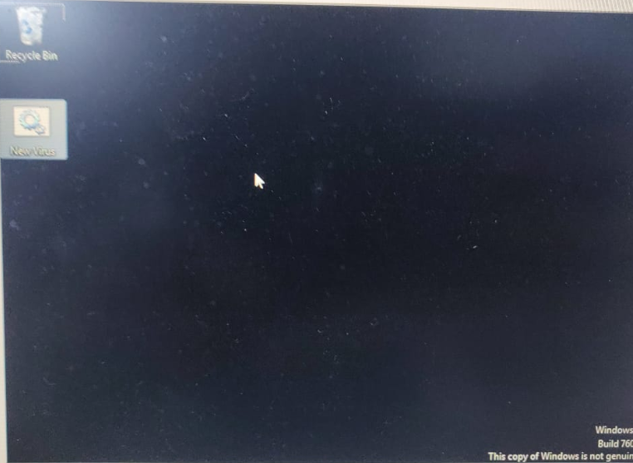

In this my mouse was disabled when I opened the new virus named file.

This is how BVM works.

And here are some ways by which we can prevent It: -

* Avoid Downloading from unknown sources.
* Install Anti-virus and Anti Malware software.
* Avoid clicking on suspected emails.
* Update your device anti-virus and anti-malware software on regular bases.
* The are some sites by which w can see if a file contains a virus or not e.g., Virus Total etc.
* Configure Firewalls.